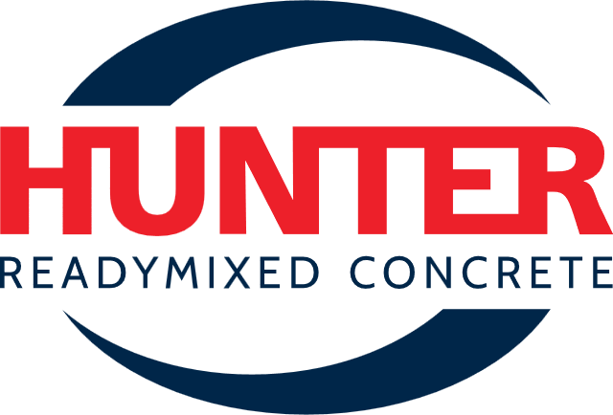
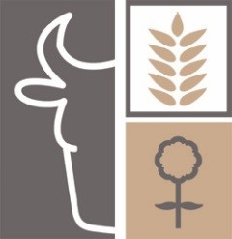
2026 MAITLAND SHOW
IN KIND (non cash)
SPONSOR APPLICATION

Fri 13 | Sat 14 | Sun 15 February 2026

SPONSOR DETAILS

Business Name: ___________________________________________________________________

Trading Name: ____________________________________________________________________

ABN: ____________________________________________________________________________

Address: _________________________________________________________________________

Suburb: ___________________________________________ Post Code _____________________

Contact person: __________________________________________

Position: ________________________________________________

Phone: ___________________________Mobile _________________________________________

Email: __________________________________________________________________________

Website: _________________________________________________________________________

Please tick: Continuing Sponsor? New Sponsor?

IN KIND SPONSORSHIP CONFIRMATION

We confirm that we provide the following In Kind (non Cash) sponsorship for the 2025 Maitland Show:

SECTION:

What is being provided by the sponsor–

What are the agreed benefits to be provided to the sponsor –
O Name or logo in section schedule
O Name or logo on website
O Opportunity to present prize at winner at the show
O Complimentary sponsor entry tickets – number to be provided:
O Other –

Signature of Sponsor: ______________________________________ Date: ______________

HRAHA Contact:

--------------------------------------------------------------------------------------------------------------------------------------------------------------------------

For office use: | Approved

